***CSS outline***

*<style>*

*.text1{*

*outline-style: dashed;*

*outline-color: red;*

*outline-width: thick;*

*border: 1px solid blue;*

*margin: 5px;*

*}*

*</style>*

***CSS position***

*<style>*

*.test1{*

*position: absolute;*

*background-color: red;*

*left: 100px;*

*top: 100px;*

*}*

*<style>*

*Note: absolute position element positioned in relation to its nearest non-static ancestor, fixed position it always have the same values, relative position keeps the previous (top, right, buttom, left)*

***CSS for hyperlinks***

***a: link*** *– default – unvisited link*

***a: visited*** *– visited link*

***a: hover*** *– when the mouse cursor is over the link*

***a: active*** *– when the link is clicked*

*<style>*

*a{*

*text-decoration: none;*

*}*

*a: link{*

*color: red*

*}*

*a: visited{*

*color: green;*

*}*

*a: hover{*

*color: pink; Note: interaction*

*}*

*a: active{*

*color: aqua;*

*}*

*</style>*

***Pseudo classes***

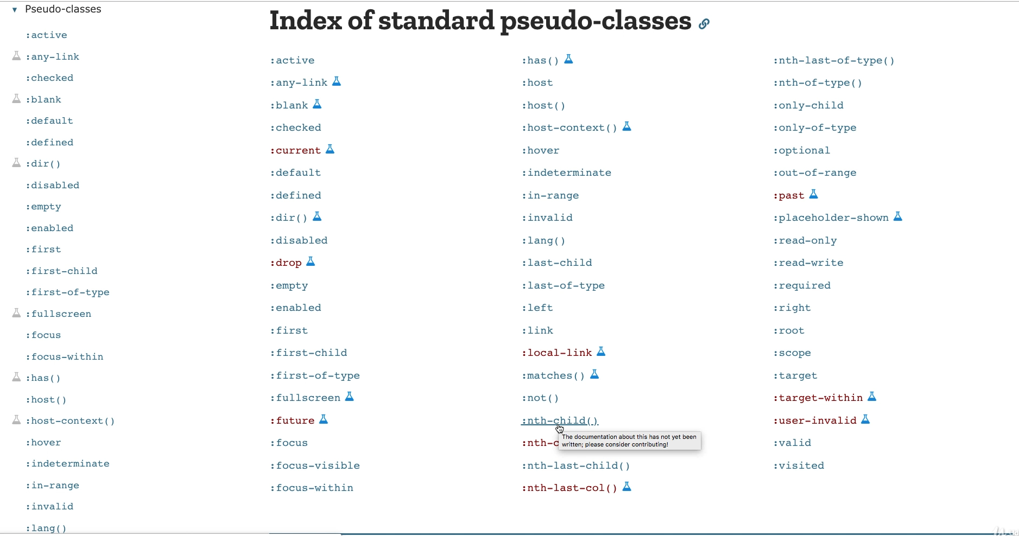

***CSS and tables***

*<style>*

*table{*

*width: 300px;*

*}*

*th{*

*background: red;*

*color: white;*

*}*

*</style>*

*<body>*

*<table>*

*<tr>*

*<th>column1</th>*

*<th>column2</th>*

*<th>column3</th>*

*<th>column4</th>*

*<tr>*

*</table>*

*</body>*

***CSS overflow and maxwidth***

*Tells the browser how to handle content that does not fit within the element*

*Max width and height force on responsive when available to restrict the height value to max*

*Overflow: [auto, scroll, hidden]*